

An Assignment on:

**Lab project of Structured Programming(C)**

**Course code**: CSE 104

**Course title**: Structured programming Lab

**Project**: **A Unit Converter**

**Submission date**: 20 Aug 2019

**Submitted to: Submitted by:**

**Babe Sultana**

Lecturer, **Group E**

Dept. of CSE (191002-) 130,129,243,374

CONTENTS

**Chapter 01**

* 1. **Introduction**
  2. **Requirement & Analysis**
  3. **Requirements**

**Chapter 02**

**2.1 Implementation of the project**

**2.2 Selection part**

**2.3 Converter part**

**2.4 Ending part**

**Chapter 03**

**3.1 Run project**

**3.2 Test project**

**Chapter 04**

$∎$**Conclusion**

$∎$**Authors**

$∎$**References**

**CHAPTER 01**

* 1. INTRODUCTION

Jarvis converter is like a tool what helps to make life easy. It helps to convert many required units in everyday life. It provides five totally different types of converter series. They are **[1] Length, [2] Temperature, [3] Currency, [4] Speed & [5] Weight**.

It converts a unit to another unit of same series or type.

* 1. Requirement & Analysis

This converter is very time saving for not only CS or mathematical problems, but also for regular need.

Some of its features are:

Converts Celsius to Fahrenheit

Converts M to KM

Converts Feet to yard

Converts KG to pounds

Converts Celsius to Fahrenheit

And **more than 50** other converting programs.

* 1. REQUIRMENTS

To make this project complete we mostly used some C compiler app like Code blocks.

And the most required thing was mathematical equations for converting certain units which was collected from internet.

**CHAPTER 02**

2.1Implementation of the project

First of all we created a new project using code blocks.

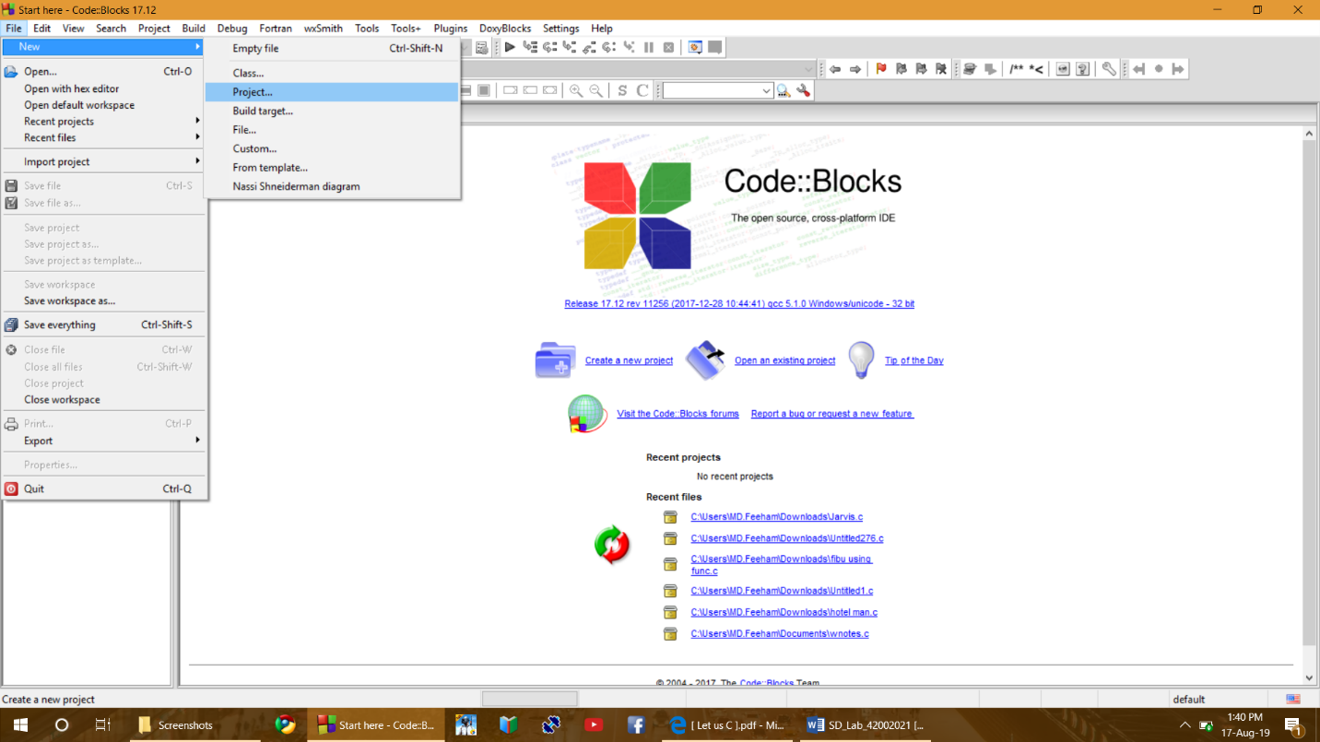

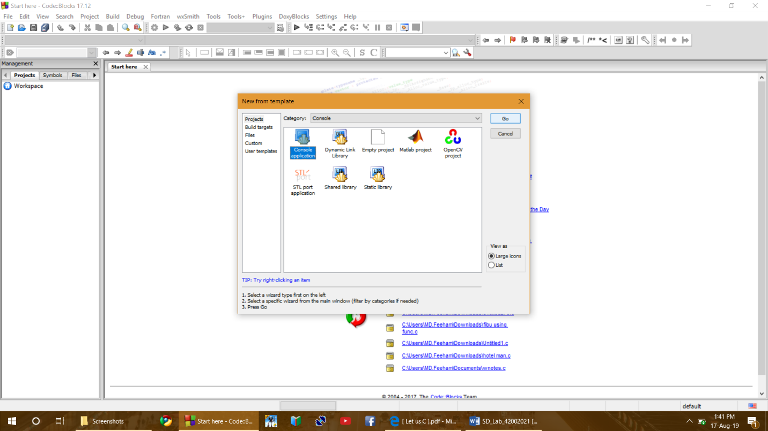

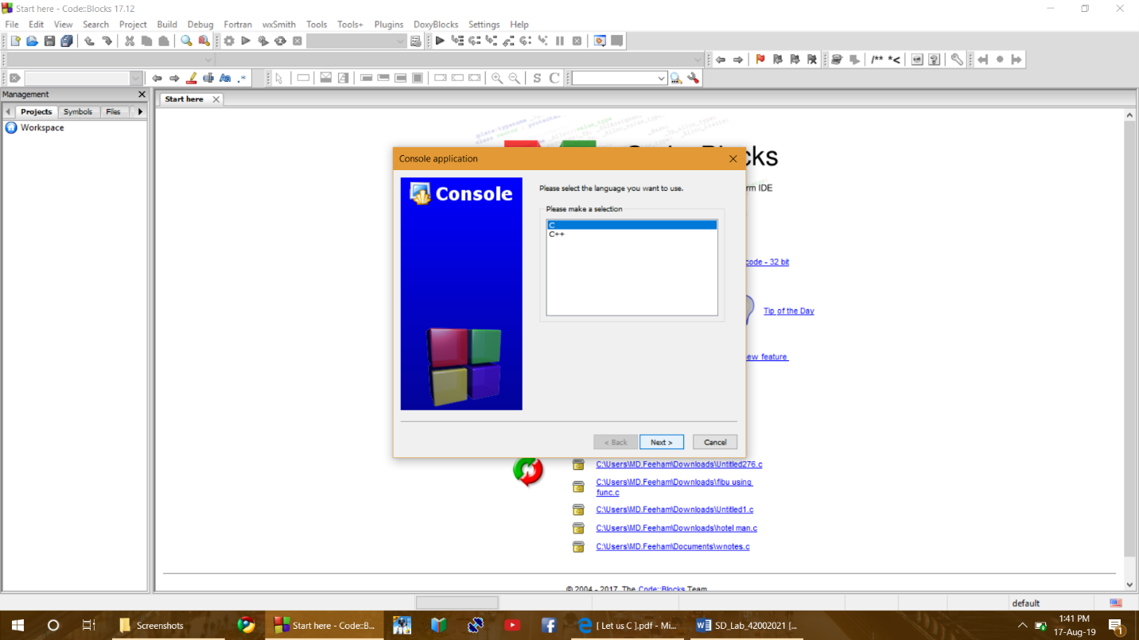

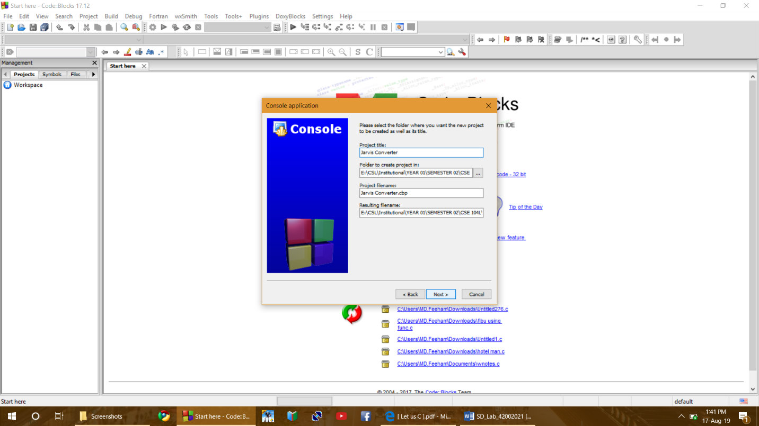

**2.2 SELECTION PART**

Then we wrote a code to have a better way to show the screen, clearing it after every step and added welcome message and instructions. Then comes selection part which let you select which type of converter you want to use. Then it goes to another selection part which let you select a certain converting function of same type you chosen before.

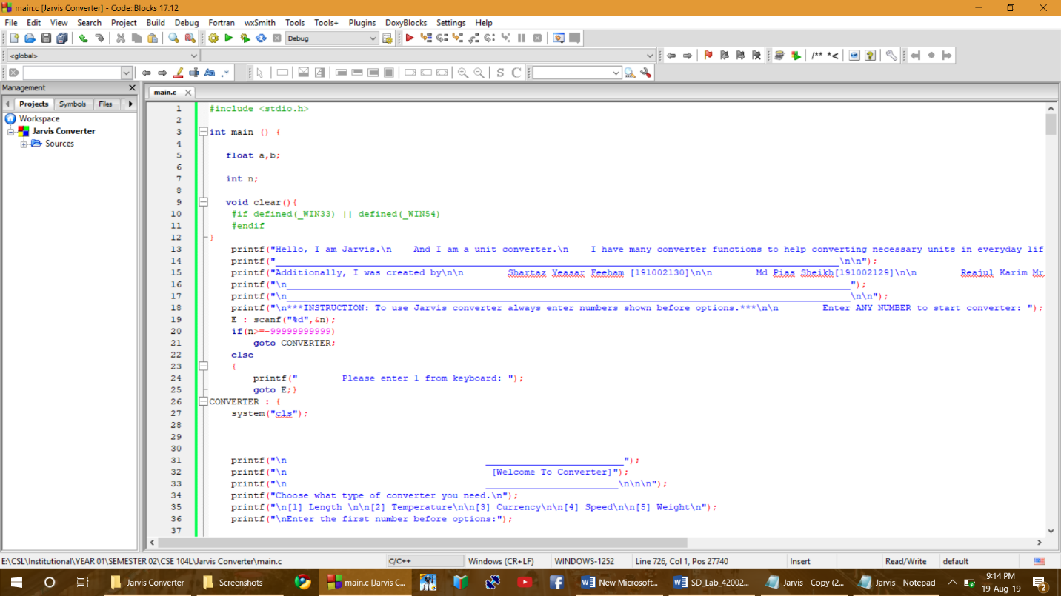

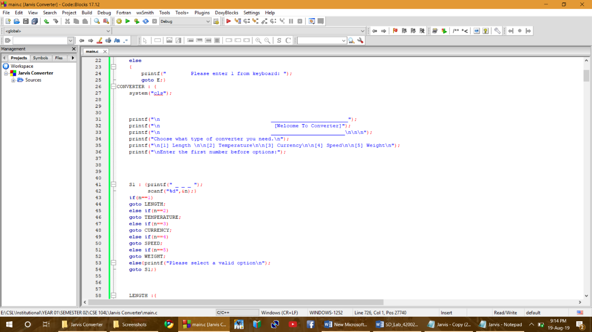

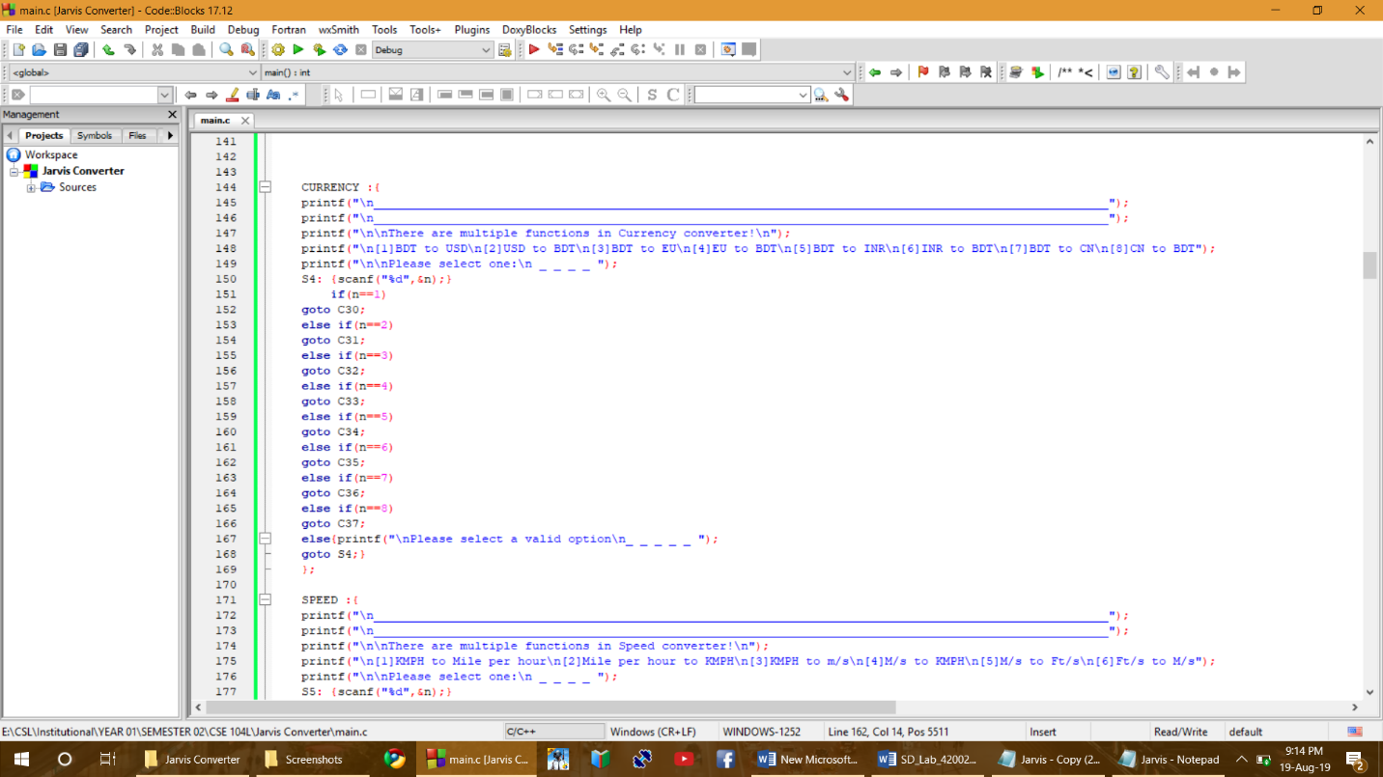

**2.3 CONVERTER PART**

Then a go to statement brings you to the certain converter you selected.

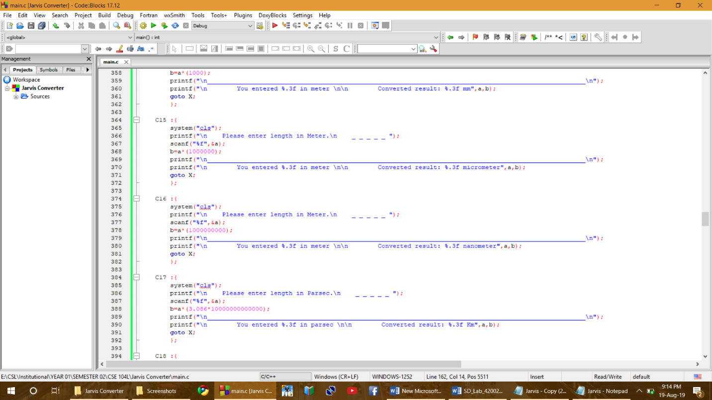

**2.4 ENDIG PART**

After you convert a unit, it will take you to the very end and will ask if you want to convert another unit or exit from Jarvis converter.

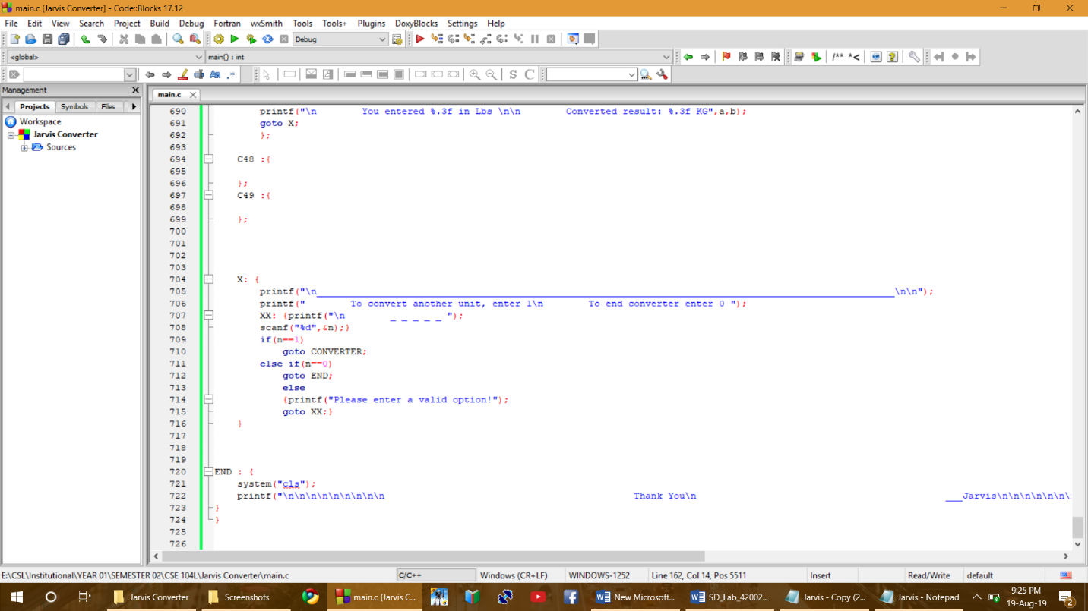

**3.1 RUN PROJECT**

We build and ran project.

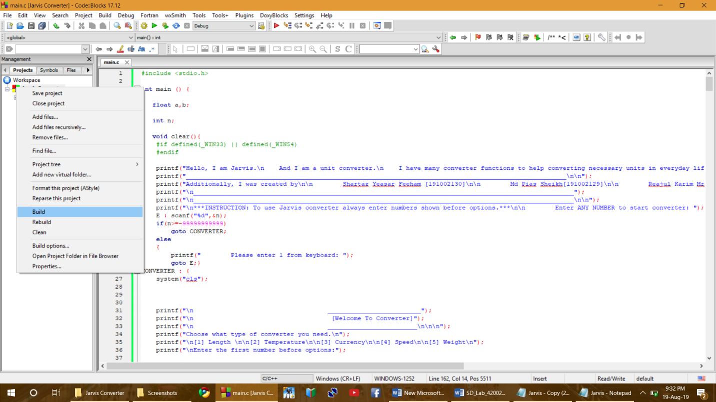

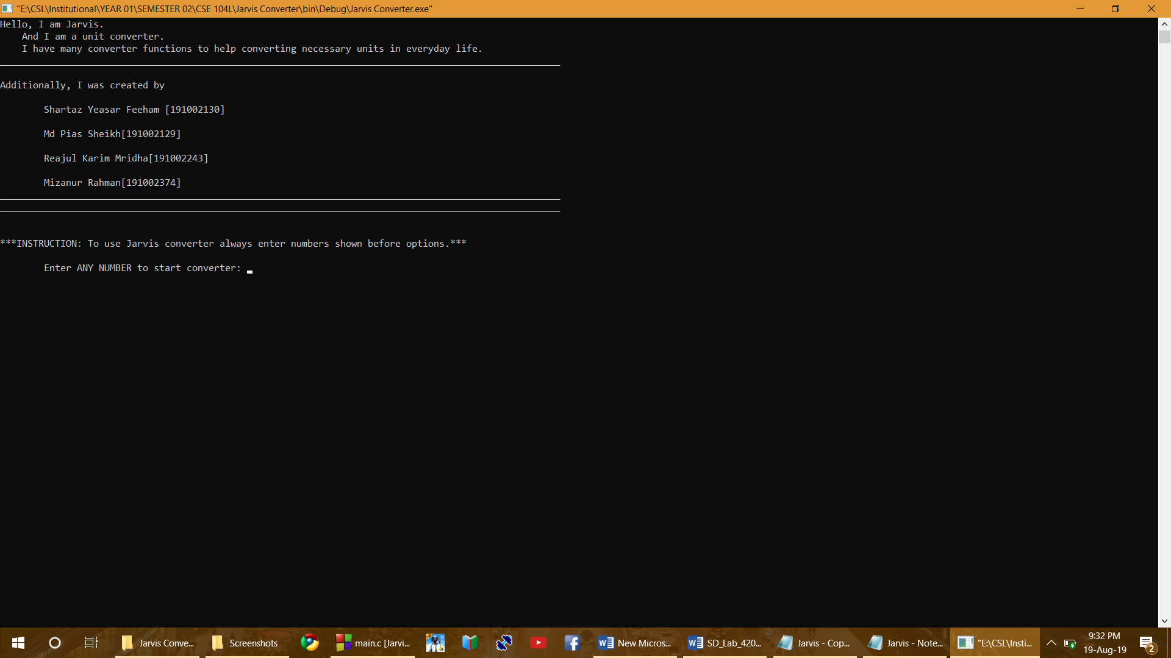

**3.2 TEST PROJECT**

We entered the program and selected length converter, after it was done we converted a temperature unit and then it successfully took us to ending part as we selected.





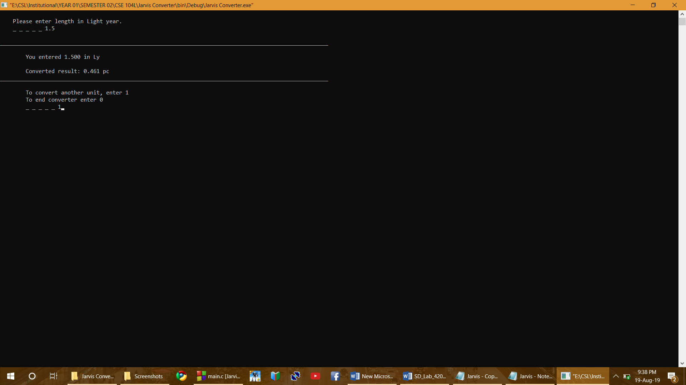







**CHAPTER 04**

$∎$**Conclusion**

It helps us to get a converted unit from another unit. Also it’s very simple to use. And makes an easier life.

$∎$**Authors**

Shartaz Yeasar Feeham [191002130]

Md Pias Sheikh [191002129]

Reajul Karim Mridha [191002243]

Mizanur Rahman [191002374]

$∎$**Refferences**

Book: Let us C

Websites: www.w3schools.com